**Distance Between Two Points**

QUESTION DESCRIPTION

This challenge involves points in two and three dimensional space. The classes and methods to implement will store values for coordinates as well as calculate distances between points. The 2D and 3D distances between two points are calculated using the following formulae:

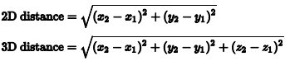

Implement the classes and methods defined below:

1. A superclass named Point2D:

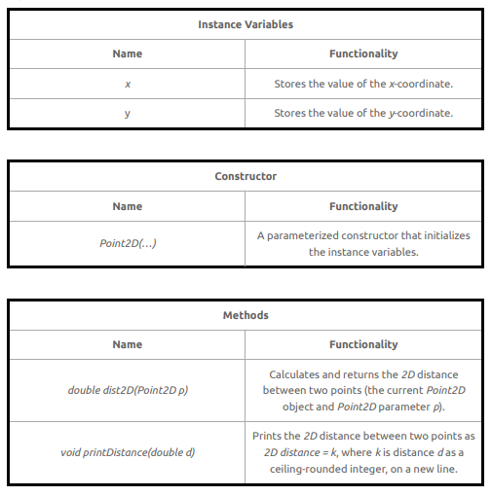

1. A derived class named Point3D that extends Point2D

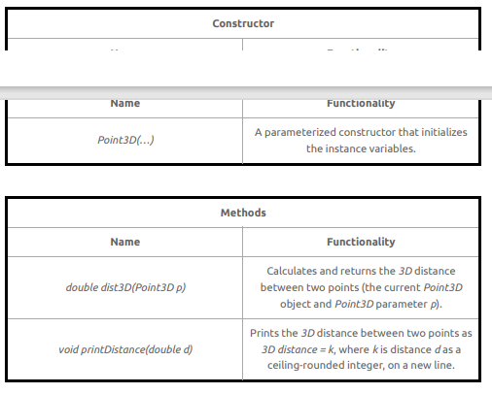

A main method is provided in the locked portion of the editor. It parses six values representing point coordinates and calls the implemented constructors and methods. Here, x[1], y[1], and z[1] represent the coordinates of the first point, and x[2], y[2], and z[2] represent the coordinates of the second point.

Note that printed output must exactly match the above for the test cases to pass.

**Constraints**

* -128 ≤ x,y,z ≤ 127

Input Format for Custom Testing

Input from stdin will be processed as follows and passed to the function.

Line: description

1. x[1]: integer

2. y[1]: integer

3. z[1]: integer

4. x[2]: integer

5. y[2]: integer

6. z[2]: integer

**Sample Case 0**

**Sample Input 0**

STDIN Function

1 → x[1] = 1

2 → y[1] = 2

3 → z[1] = 3

4 → x[2] = 4

5 → y[2] = 5

6 → z[2] = 6

**Sample Output 0**

2D distance = 5

3D distance = 6

**Explanation 0**

* For the first point: x = 1, y = 2, z = 3.
* For the second point: x = 4, y = 5, z = 6.
* The formula gives a 2D distance of sqrt(3 + 3 ) = 4.242640687119285. The ceiling is 5.
* The formula gives a 3D distance of sqrt(3 + 3 + 3 ) = 5.196152422706632. The ceiling is 6.

**Sample Case 1**

**Sample Input 1**

STDIN Function

-1 → x[1] = -1

-2 → y[1] = -2

4 → z[1] = 4

-7 → x[2] = -7

-1 → y[2] = -1

-1 → z[2] = -1

**Sample Output 1**

2D distance = 7

3D distance = 8

**Explanation 1**

* For the first point, x = -1, y = -2, z = 4
* For the second point, x = -7, y = -1, z = -1
* The differences are x: -6, y: 1, z: -5
* The squares of differences are x: 36, y: 1, z: 25
* 2D distance calculation: sqrt(36+1) = 6.08276253, ceiling = 7
* 3D distance calculation: sqrt(36+1+25) = 7.874007874, ceiling = 8

**CANDIDATE ANSWER**

Language used: Java 8

// Write your class implementations here. Do not use access modifiers when declaring your classes.

// Write your code here